**Database Systems**



**DOCUMENTATION**

***Player Profile Network***

**Submitted by:**

Ammar Anees(20-CS-053)



Sir.Adnan Javed

1

3

th

JAN

, 202

3

HITEC University, Taxila Cantt.

**Submitted to:**

**ACKNOWLEDGEMENTS**

First of all, I am very Thankful to **Allah Almighty**, Parents and my teachers who have supported me especially thanks to our supervisor “**Sir.Adnan Javed**”

This project is completed by the student of **CS-2020**,”**Muhammad Ammar Anees**”.

I completed this project and this is brief report of the project which I made in this semester.

## **Abstract**

The main purpose of this detailed presentation is to understand the major concepts that how we verify database systems, what is database, Different phases of building a database. As you know the technology is on its peak so we also have to develop the systems which solve today’s problem and we also have to compete with the world.

**Introduction:**

Database Management Systems (DBMS) are **software systems used to store, retrieve, and run queries on data**. A DBMS serves as an interface between an end-user and a database, allowing users to create, read, update, and delete data in the database.

**Tools:**

Apache Netbeans(Json Interface)

MySQL(Database)

INTELLIJ IDEA Community Edition 2022

JAVA language

J-frames

**Screenshots:**

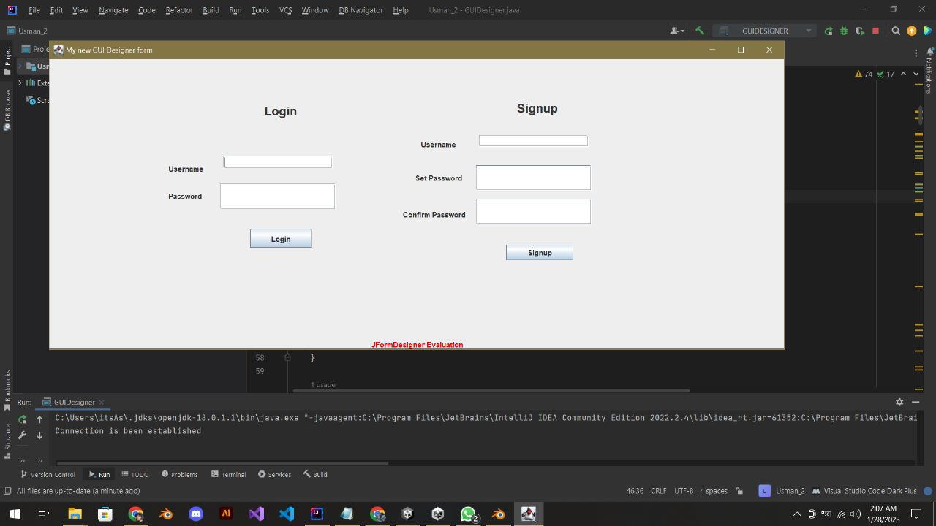

User can signup and login account at anytime with ease and correct password is mandatory for signin.

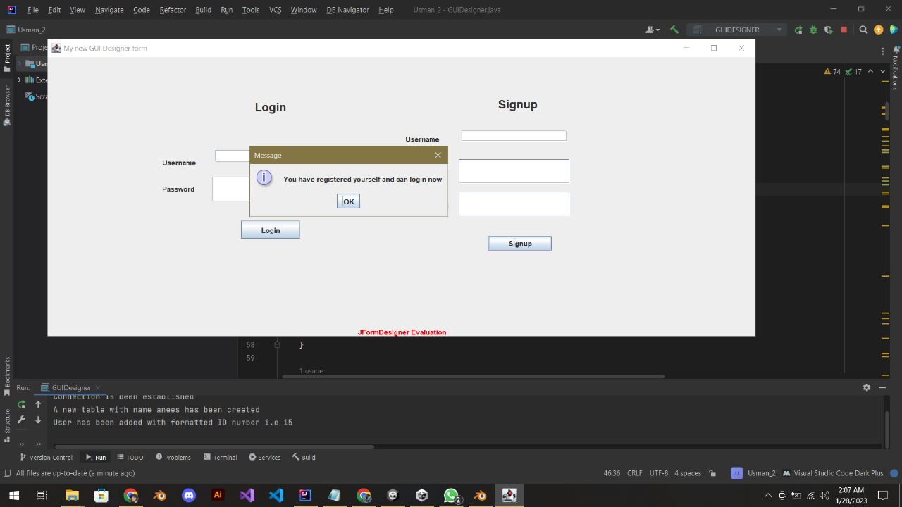

Special Notification is shown right after registering the personal information for account.

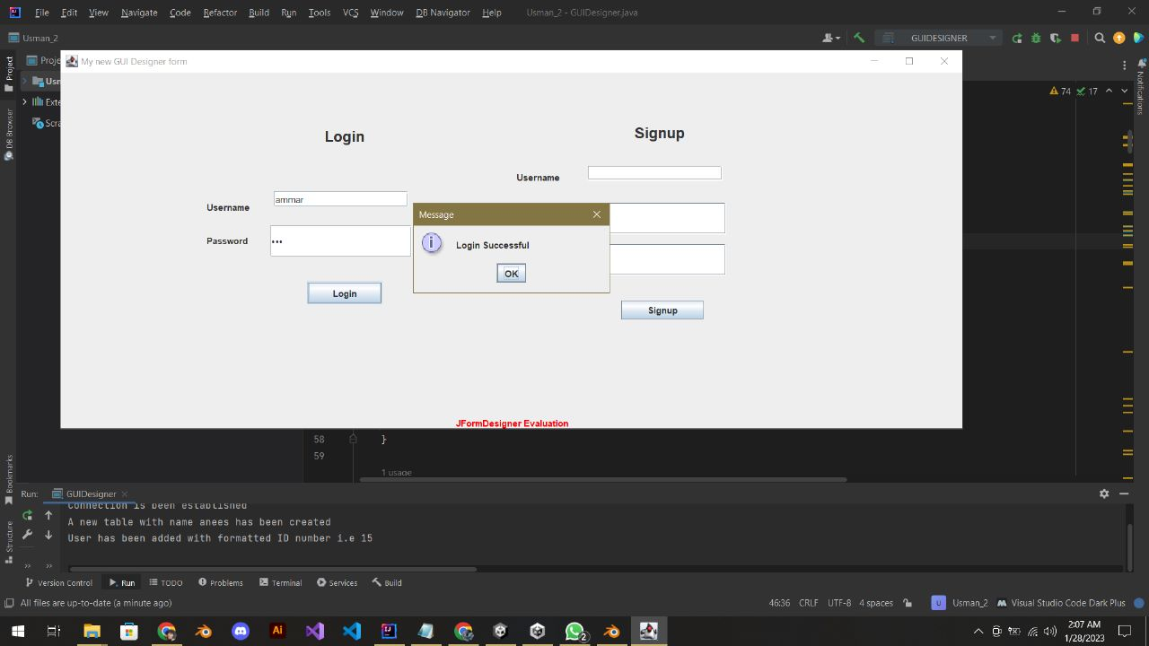

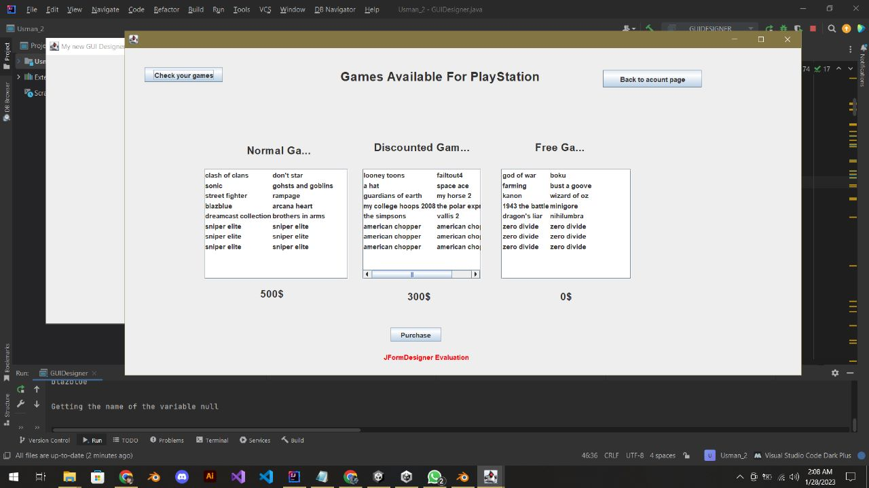

Multiple games at different prices/discounted rates are available for user after registering the account as shown in above image

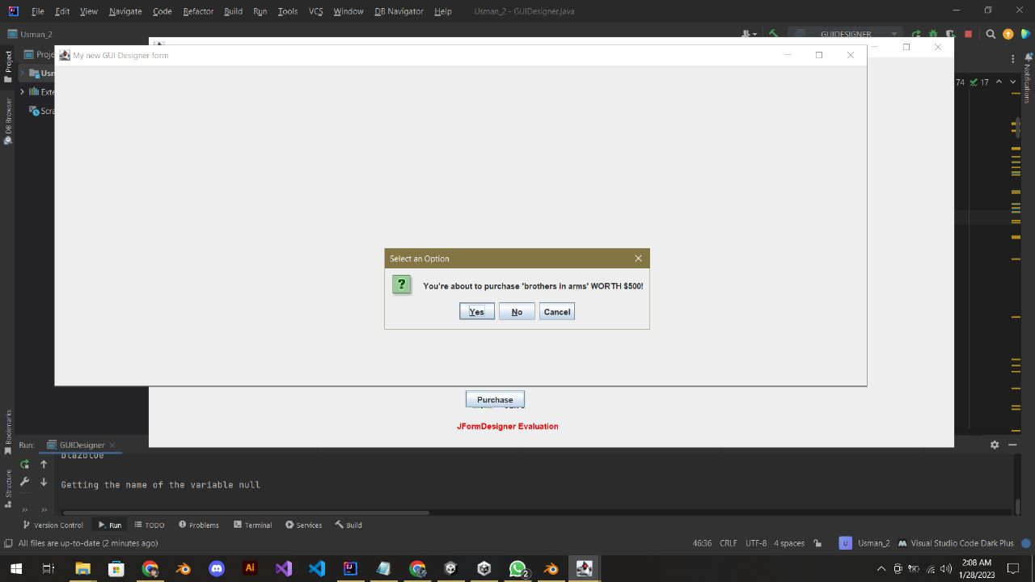

Purchase request is made for user to select an option as YES/NO/CANCEL.

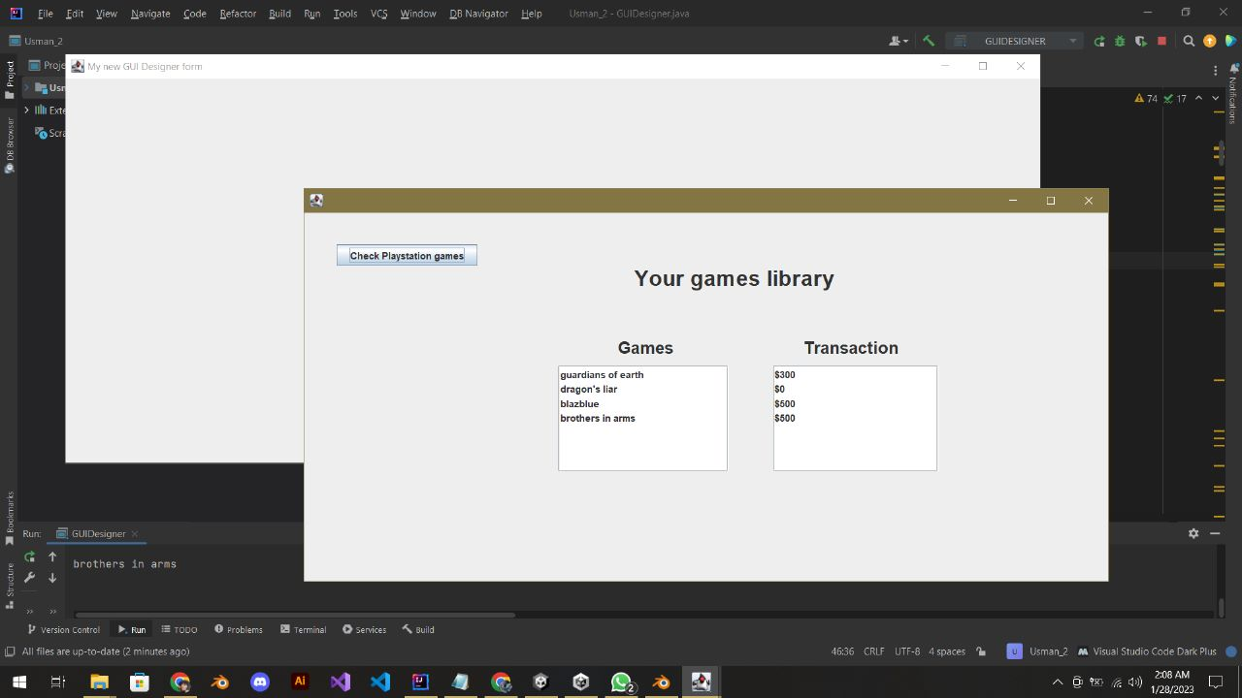

The games that user will buy will be directed to user library with transaction amount as shown.

|  |  |
| --- | --- |
|  | **Conclusion:**  Databases are very important to store data in big companies.  We can easily retrieve data at anytime.  It is easy for us to monitor database activity.  There is login/logout option for personal user id.  User can buy multiple games and purchase record is kept in database.  I have prioritized user friendly environment and user’s ease. |